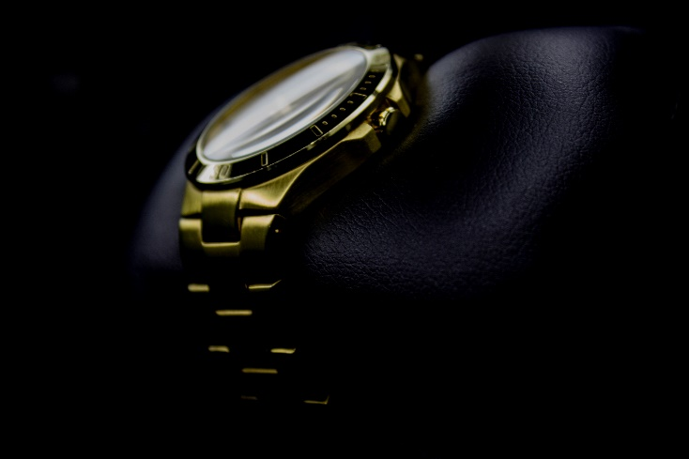

**The demand for luxury watches is exceeding supply – what should you do if you own a luxury timepiece?**

Supply chain shortages, the disruption of the pandemic and delays in production outputs and delivery schedules have led to a soaring demand for pre-owned luxury timepieces like Rolex, Richard Mille, Audemars Piguet and Patek Philippe.

There are long waiting lists if you want to purchase a new steel Rolex, and if you want a collectable like a Daytona Cosmograph it’s highly improbable. The situation looks unlikely to change as Rolex for instance have no plans to increase production to meet demand and in fact have increased their prices to rebalance their losses during the pandemic.

This demand spills over into the used market and pushes up the price of watches as buyers choose to buy a pre-loved piece rather than wait. For you, this means that if you have a coveted watch that is in demand, the price it is now worth will probably be more than it’s insured for. This leads to underinsurance, and put simply, means that your insurance policy may not cover you for the full replacement amount of the same make and model if you had to make a claim.

Normally, obtaining a valuation every five years is considered good practice, but considering these events we suggest this is reduced to three years. Encouragingly, most insurers offer Extended Replacement Cover if this is supported by a recent valuation, and you could benefit from an uplift on the sum insured ranging from 25% to 50%, so it makes sense.

You should also send a copy of your valuation to your broker, photograph your items, keep them in good condition and keep all aspects of their provenance in a safe place. These will all help if you have to make a claim.